|  |  |  |
| --- | --- | --- |
| **Report IDM reference No.** | EFDA_D_2NGBBF | **Version: see IDM** |

Final Report

on Deliverable

*MAT-1.2.2-T009-D001 - Database Population - Advanced Steels and High Heat Flux Materials(2016)*

|  |  |  |  |
| --- | --- | --- | --- |
|  | | **Deliverable-ID**[1] | MAT-1.2.2-T009-D001 |
| **Work Package** | *WPMAT* | **Date** | *27 Oct. 2015* |
| **Project Leader** | *M. Rieth* | | |
|  | | | |
| **TS Title** | *Database Population- Advanced Steels and High Heat Flux Materials (2016)* | | |
| **TS Ref. No.** | *MAT-1.2.2-T009* | **TS IDM-link** | *https://idm.euro-fusion.org/?uid=2MSSFM* |
| **Task Owner** | *Ermile Gaganidze* | | |
| **RU(s)** | *KIT* | | |

|  |  |
| --- | --- |
| **Report Review & Approval** | |
| **IDM role** | **Name(s)** |
| **Author** | *E. Gaganidze* |
| **Co-author(s)** |  |
| **Reviewer(s)** | *M. Gorley* |
| **PMU Reviewer** | *E. Diegele* |
| **Approver** | *M. Rieth* |

|  |  |  |  |  |  |
| --- | --- | --- | --- | --- | --- |
|  | Study / Assessment |  | Procurement / Commissioning of Hardware |  | Industry |

|  |  |  |  |
| --- | --- | --- | --- |
|  | Use of Facility | X | Database population |

|  |
| --- |
| **Executive Summary** |
| *The population of the EDDI Advanced Steel and High Heat Flux Materials databases is furtherly advanced. Compilation of the data generated in the MAT-AS and MAT-HHFM sub-projects within 2015 is performed. Verification of the data with respect to the completeness of the provided information is carried out. The missing information is filled on the base of the feedback of principle investigator of relevant tasks. The mechanical properties data generated within HHFM sub-projects have been transferred into the EDDI database templates. The available literature data on EUROFER97 not included yet in the EDDI database have been transferred into the database.* |

|  |
| --- |
| **Comments** (shortcomings, deviations, etc.) |
|  |

*{Guidance on Report format given below, this is not mandatory and can be modified as required}*

**Table of Contents**

1 Short Introduction and Objectives of Work 2

2 Description of Work 2

3 Conclusion 6

4 Reference 6

**Abbreviations**

|  |  |
| --- | --- |
| *AS* | *Advanced Steels* |
| *DDC* | *DEMO Design Criteria* |
| *DEMO* | *Demonstration fusion reactor* |
| *EDDI* | *Engineering Data and Design Integration* |
| *FCG* | *Fatigue Crack Growth* |
| *HHFM* | *High Heat Flux Materials* |
| *KIT* | *Karlsruhe Institute of Technology* |
| *LEFM* | *Linear Elastic Fracture Mechanics* |
| *PI* | *Principle Investigator* |
| *RAFM* | *Reduced Activation Ferritic/Martensitic* |
| *TMT* | *Thermo-Mechanical-Treatment* |

# Short Introduction and Objectives of Work

The development of the DDC for in-vessel components of a future DEMO requires building of the sound database on structural, armour and functional materials comprising relevant properties both in the unirradiated and irradiated states. Close work with the material sub-projects aiming at the development of advanced steels and high heat flux material for DEMO in-vessel components is important in order to get an idea of the advanced fabrication routes and methodologies used for characterization of materials. The acquired knowledge should be used for the development of data collection templates providing adequate documentation of the testing results and enabling reviewing the data against the previously agreed EUROfusion EDDI Database quality thresholds ([*2M9HTV*](https://idm.euro-fusion.org/IDM/Pages/DocumentView.aspx?uid=2M9HTV)).

The main objectives of the current work was the continuation of the building of EDDI database on the advanced steels (1) and high heat flux materials (2) as well as the development of new data collection templates to cover additional specific testing needs.

# Description of Work

**Development of data collection templates for steels**

Following the structure of the EDDI steel data collection templates available on IDM (*2MEWKA*) a new template has been developed for the collection of the Fatigue Crack Growth (FCG) data, see IDM reference (*2MLK64*). The provided template guarantees full documentation of the material properties enabling traceability from product information to the testing results. Furthermore, the templates satisfy material code qualification needs and can be used in the future for this purpose.

Figure 1 shows a *cutaway* from the developed FCG template together with the corresponding glossary, (IDM reference *2MLK64*). Three different categories of entries i.e. number, text and container can be identified for the storage of numerical values, text information or graphical/electronic information (e.g. file name), respectively.

|  |  |
| --- | --- |
|  |  |
|  | |
|  | |
|  | |
|  | |

Figure 1 Cutaway from the Fatigue Crack Growth template and corresponding glossary. Data stem from (3).

**AS Database population**

The data generated in the MAT-AS sub-project in the course of WP 2015 have been compiled and verified with respect to the completeness of the provided information. MAT-AS data have been provided in EDDI database templates. The identified missing information (unambiguous identification of material, specimen orientation, testing parameter, etc.) has been requested from the PIs of relevant tasks.

The current status of the advanced steel database is summarized in Table 1.

|  |  |  |
| --- | --- | --- |
| Property/Information | Data source | No. of records |
| Composition of advanced RAFM steels | SCK-CEN, KIT | 20 |
| Composition of advanced ODS RAFM steels | CEIT | 15 |
| Product information of advanced RAFM steels | SCK-CEN | 41 |
| Product information of advanced ODS RAFM steels | CEIT | 19 |
| Hardness of advanced RAFM steels | KIT | 120 |
| Impact properties of advanced RAFM steels | SCK-CEN | 23 |
| Tensile properties of advanced RAFM steels | SCK-CEN | 28 |

Table 1 Status of the advanced steel database

Figure 2 shows exemplarily tensile and impact properties of 9%Cr-RAFM steels with optimized composition and modified thermal and thermo-mechanical heat treatments developed in (4). The results are compared with the corresponding trend curves for EUROFER97 from DEMO MPH. Though the tensile strength properties are slightly lower than the corresponding properties for EUROFER97, the DBTT of all advanced steels are better than the lowest value of the DBTT observed for selected product forms of EUROFER97.

|  |  |
| --- | --- |
|  |  |

Figure 2 Left: Points show the Yield Strength of the advanced 9%Cr-RAFM steels (4). The solid line is the average curve for EUROFER97 from DEMO MPH (5) whereas the dashed line shows the minimum curve from the same document. Right: Points represent the impact energy of the advanced 9%Cr-RAFM steels. The dashed lines show the two outmost impact energy vs. temperature trend curves for EUROFER97.

**HHFM Database population**

The data generated in MAT-HHFM sub-project in the course of WP 2015 have been compiled and verified with respect to the completeness of the provided information. MAT-HHFM data have been provided in HHFM templates. The identified missing information (unambiguous identification of material, specimen orientation, testing parameter, etc.) has been requested from the PIs of relevant tasks.

Mechanical and thermos-physical properties data generated within MAT-HHFM subproject have been transferred into the EDDI database templates. The data transferred in EDDI database templates is summarized in Table 2.

|  |  |  |
| --- | --- | --- |
| Property/Information | Data source | No. of records |
| Bending properties of W alloys  (W-30CuCrZr, W-30Cu, W-Cr10Ti2, W-15Ta) | UPM | 31 |
| Tensile properties of W alloys  (W-30CuCrZr, W-30Cu, W-Cr10Ti2, W-15Ta) | UPM | 14 |
| Fracture Toughness of W alloys  (W-30CuCrZr, W-30Cu, W-Cr10Ti2, W-15Ta, pure-W, WVM-foil) | UPM, ÖAW-ESI | 60 |
| Impact properties of W laminates  (W-Cu, W-V) | KIT | 11 |
| Thermo-physical properties of W alloys  (WCr10ti2-HIP, WCr10Ti2-HIP+1600C, WCr15) | CEIT | 30 |

Table 2 HHFM data transferred into EDDI database

Figure 3 shows cutaway of the fracture-mechanical properties of the tungsten foils (6).



Figure 3 Cutaway of the fracture-mechanical properties of W foils generated by ÖAW (6).

Fracture toughness data determined on different tungsten alloys are summarized in Figure 4. For one part of the data applicability of the LEFM could be followed on the base of the required records in the database. In such case the invalid data is represented by open symbols. For the case where the applicability of the LEFM cannot be judged the results are represented by the crossed symbols. The composite W30CuCrZr as well as W30Cu materials show superior room temperature conditional fracture toughness KQ, whereas the conditional fracture toughness values of W15Ta (IST) and WCr10Ti2 (CEIT) are comparable to the fracture toughness of the round blank tungsten for its weak orientation.

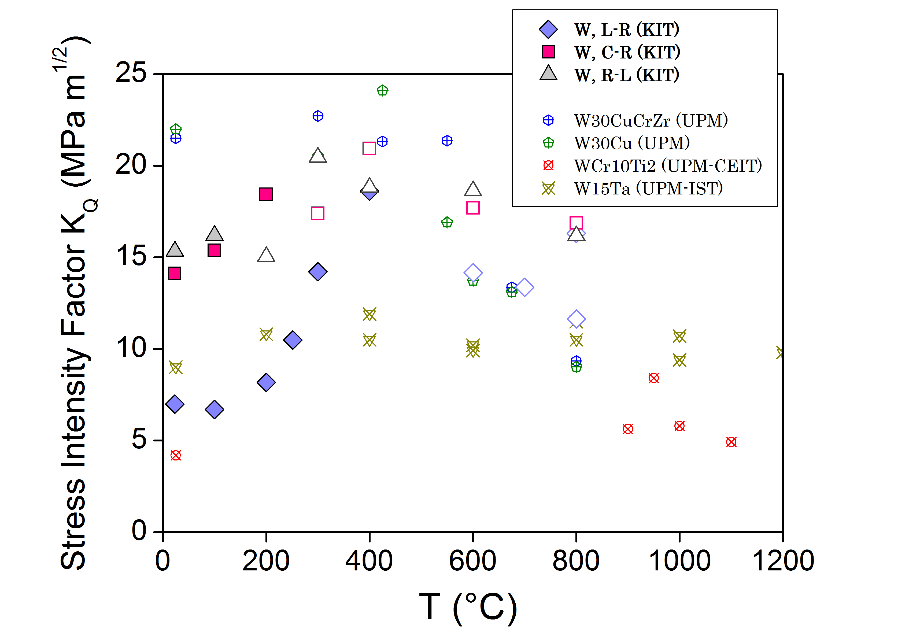

Figure 4 Conditional Stress intensity Factors KQ for different tungsten alloys vs. test temperature. The RUs performing the tests are indicated in the parentheses of the figure caption. For the KIT data the test results where LEFM is no more applicable are represented by open symbols. These values give the lower bound of the fracture toughness. For UPM data (7) no differentiation could be done between valid and invalid data as the applicability of LEFM could not be followed.

The Material Fabrication and HHF testing results are kept in original HHFM templates. Rather different fabrication routes applied for different materials makes the development of universal templates complex. Reasonably such templates should be developed after demonstration of performance level relevant for application under high heat flux loading conditions. For the list of the available data see Table 3.

|  |  |
| --- | --- |
| Property/Information | Data source |
| Composition, fabrication route of reinforced W alloys  (W-Si-C, W10PF, W10G, SiCf/W-Ti) | JSI |
| Composition, fabrication route of PIM W (W, W-1TiC, W-2Y2O3, W-2La2O3, W-2TaC) | KIT |
| Composition, fabrication route of W laminate  (W-Cu, W-V) | KIT |
| Composition, fabrication route of *pure, alloyed* and *rigid* fillers powders (Cu-20Ti) | CIEMAT-URJC |
| fabrication route of W-Eurofer brazed joints (+Vickers HV0.1 hardness)  (W substrate + Eurofer substrate + Cu-20Ti filler) | CIEMAT-URJC |
| Composition, manufacturing of thermal barriers  (25WC-75Cu, 50WC-50Cu, 75WC-25Cu) | IST |
| High Heat Flux testing of tungsten alloys  (IGP, PIM-W, W-SiC, W-Cr-Ti) | FZJ |

Table 3 HHFM data kept in original HHFM templates

# Conclusion

The Population of the EDDI Advanced Steel and High Heat Flux Materials databases is furtherly advanced. Compilation of the data generated in the MAT-AS and MAT-HHFM sub-projects within 2015 is performed. MAT-AS data has been provided in EDDI database templates and MAT-HHFM data has been provided in HHFM templates. Verification of the data with respect to the completeness of the provided information is carried out. The missing information is filled on the base of the feedback of principle investigator of relevant tasks. The mechanical properties data generated within HHFM sub-projects have been transferred into the EDDI database templates. The available literature data on EUROFER97 not included yet in the EDDI database have been transferred into the database.

# Reference

1. E. Gaganidze and Mario Walter, Structural Steels Database Development and Population, Final Report on Deliverable MAT-1.2.2-T3-D1, IDM Reference No. *2MH9KU*, KIT, 2015.

2. E. Gaganidze, M. Conte, Database Population – Armour & Composite Material Database Development and Population, Final Report on Deliverable MAT-1.2.2-T6-D1, IDM Reference No. *2MHACW*, KIT, 2015.

3. J. Aktaa, M. Lerch, Near-threshold fatigue crack behaviour in EUROFER 97 at different temperatures, Journal of Nuclear Materials 353 (2006) 101-108.

4. A. Puype, L. Malerba, Development of a Modified Genetic algorithm for the selection of 9%Cr RAFM steels optimized for high temperature application-Characterization of produced steel batches, Final Report on Deliverable MAT-2.2.1-T2-D5, IDM Reference No. *2MUYYM*, SCK-CEN, 2016.

5. F. Gillemot, E. Gaganidze, I. Szenthe, Material Property Handbook, Pilot Project on EUROFER97, IDM Reference No. *2MRP77*, MTA EK, KIT, 2016

6. V. Nikolić,P. Kutleša, R. Pippan,Results on fracture toughness experiments and microstructural analysis on tungsten foils/laminates, Final Report on Deliverable MAT-3.8.1.T2-D4, IDM Reference No. *2MP7FF*, ÖAW, 2015

7. J. Y. Pastor, T. Palacias, E. Tejado, A. Martin, Results on the mechanical, microstructural and fractographical characterization of plasma facing and heat sink materials, Final report on Deliverable MAT3.8.1-T2-D5, IDM Reference No. *2MLGSK*, CIEMAT-UPM, 2015

1. One *Deliverable Report* shall be submitted for each deliverable e.g. Study Report, Commissioning Report, Final Assessment Report, Technical Acceptance Report, Procurement Report, etc.